The History of Literacy
Literacy is a skill that many people in our modern time take for granted. Literacy is a term that has been co-opted to be aptitude or skill in a certain area or with a certain tool/program/technology. Traditionally though, it referred almost exclusively to the ability to read and write and that is how I will be using it for this project. Today, many countries are at the 99% mark for literate citizens, and the world as a whole was at 85% as of 2010.
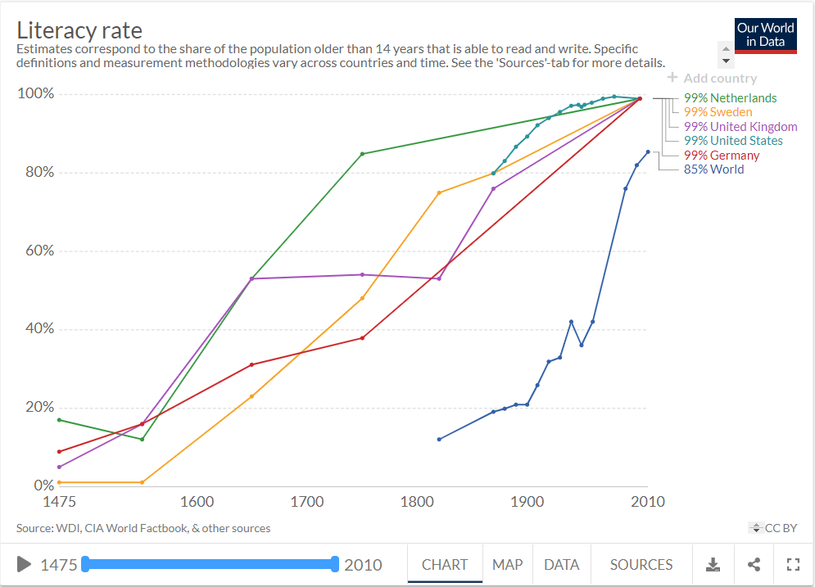
These literacy rates are in stark contrast to 300 years ago when the top two countries had only 85% and 54% of their citizens being literate, and to 500 years ago when even the most literate countries were hovering around 16%, and most hovered very nearly to 0%.
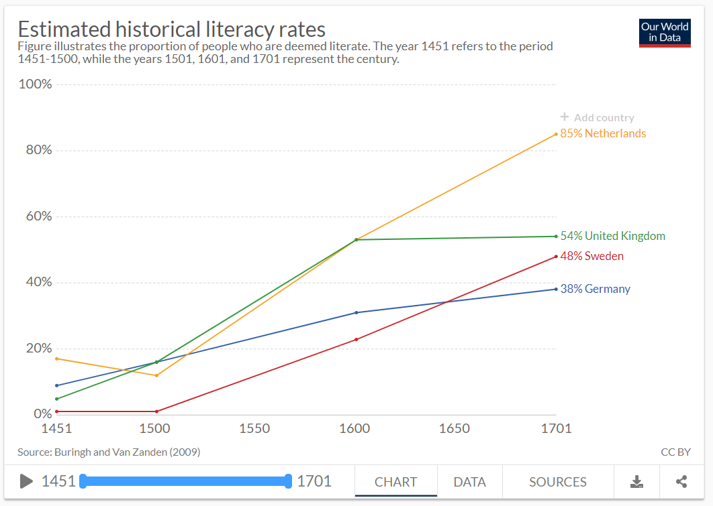
The majority of this data is extrapolated from “signing rates” on legal documents in European countries. People getting married or going to court that could sign the legal documents were assumed to be literate.^{[3]} Additionally, inventories of the deceased were used as an indicator to see how many books the average person owned. The numbers that are more modern are from census data from their respective countries, and other accurate estimates where that information is not available.
This is not an extensive deep dive into the history of literacy or all the factors that led to its increase for the entire world. The reasons for one countries’ improvement in literacy rates over the past 500 years could easily fill a Harry Potter sized collection of books. This is instead a snapshot of a few European countries since they have the longest standing data on the subject, and estimated world literacy rates throughout the past 500 years. I hope to provide context of the time in these countries by highlighting popular works and authors, and by detailing who were the “literate” and how/why they had these skills when so many others didn’t. Finally, I will emphasize some of the largest factors that led to the most literate countries gaining their spots, and to some modern efforts to improve the position of the countries that lag behind.
Pre 1500
Before the 1500’s, literacy rates were pretty dismal. No country at this time, or at any time prior in history had ever had a literacy rate of greater than 20%, and most were at 5% or lower. The major works of the time tended to be primarily secular works and the majority of the literate were either merchants that needed to keep ledgers, slaves or lowly workers that were used to transcribe documents. The remaining vast majority of the literate were members of the clergy that could read and write in order to preach on the scripture and make copies of holy works. (Wikipedia) In fact, most of the works circulating at this time were somewhat religious in nature. There were secular works that existed throughout these centuries including Beowulf, The Canterbury Tales, and The Divine Comedy but the vast majority of works were religious.(Wiki-Medival)
Low rates of literacy can be attributed to a few main factors. The hierocracy of Europe had no need to educate peasants, so public schooling was non-existant and reserved for the elite. Additionally, before the invention of the printing press, books were reproduced by hand, or by placing block letters together, which made access to books both uncommon due to their rarity and expense. After the invention printing press in the 1440’s, the first of which reprinted the bible, books started to become more prevalent and access to reading material slowly became more common, but there was still a long span of time before literacy would greatly improve.
1500’s
Literacy Rates
Literacy
- Who was literate
- What did these people do?
- Why were they literate
- Improvement? People/ reasons behind movements to improve literacy.
Popular works/ Authors of the 16th Century
The majority of works at this time remained religious, notable works and authors of the early 1500’s were Martin Luther, who wrote the Luther Bible New Testament, and Copernicus, who wrote his heliocentric theory of the universe. Later in the 1500’s there was still a vast amount of religious works being written, but we are also given the first of Shakespeare’s works, including Romeo and Juliet.

1600’s
Literacy Rates
Literacy
- Who was literate
- What did these people do?
- Why were they literate
- Improvement? People/ reasons behind movements to improve literacy.
Popular works/ Authors of the 17th Century
The start of the 17th century is filled with the prolific writing of Shakespeare. He released over a dozen of his greatest works in the first two decades of this century. The rest of the 1600’s have notable work’s by Sir Francis Bacon, the philosophical works of Descartes, novels by John Milton including Paradise Lost, and finally the works of Newton in the later part of the century.
1700’s
Literacy Rates
Literacy
- Who was literate
- What did these people do?
- Why were they literate
- Improvement? People/ reasons behind movements to improve literacy.
Popular works/ Authors of the 18th Century
During the 18th century a shift occurs in regards to the types of books people start to read and own. Based off of inventories of the deceased in the most literate European countries, the start of the century began with roughly half of all books owned by the literate were religious in context, but by 1783, that number dropped to less than 30%. This century was the turning point for literature that marked the start of the meteoric rise of reading for pleasure more than piety that persists well into modern times.
Significant works of this time include
1800’s
Literacy Rates
Literacy
- Who was literate
- What did these people do?
- Why were they literate
- Improvement? People/ reasons behind movements to improve literacy.
Popular works/ Authors of the 19th Century

1900’s
Literacy Rates
Literacy
- Who was literate
- What did these people do?
- Why were they literate
- Improvement? People/ reasons behind movements to improve literacy.
Popular works/ Authors of the 20th Century

2000’s/Present
Literacy Rates
Literacy
- Who was literate
- What did these people do?
- Why were they literate
- Improvement? People/ reasons behind movements to improve literacy.
Popular works/ Authors of the 21st Century
For this century, there’s not even a point to try and highlight authors or works. We are all living through it and the vast amount of books and authors that are popular today is magnitudes greater than in previous centuries and it would be pointless to highlight any other work, beside maybe Harry Potter. This is simply due to it being the highest selling book series of all time, making it a clearly impactful and significant work (Wiki 3). Additionally, the first book in the series (actually published in 1997) is one of only six non-religious books to have sold over 100 million copies, with the second most recent being The Lord of The Rings (published as one book) from 1955.

ROUGH DRAFT THOUGHTS/QUESTIONS
- I don’t have each (or any) time period fully finished, but are there aspects or information that you would like to see me cover (or not cover)?
- I am thinking of highlighting each author/ work a bit more with a brief descriptions/2 sentence synopsis of the piece, Is that worth the effort?
- I am planning on using Adobe Spark to make a website with one page for each century, where the background changes as you scroll to reflect the content that is currently displayed, any tips/tricks/suggestions for this format or for any alternative?
- Was there something that you really liked or really didn’t like? I know it’s hard to say with 80% of it being framework but I would love comments/criticism/thoughts/feelings/funny jokes

References
https://en.wikipedia.org/wiki/List_of_years_in_literature
https://en.wikipedia.org/wiki/Medieval_literature#Religious
Mkandawire
http://dspace.unza.zm:8080/xmlui/bitstream/handle/123456789/5305/Literacy%20Versus%20Language%20Sitwe%20Article.pdf?sequence=1&isAllowed=y
https://en.wikipedia.org/wiki/List_of_best-selling_books#List_of_best-selling_book_series

